AWS IAM Assignment Documentation
Objective: Complete IAM tasks and capture screenshots for each step.

Task 1
Create one IAM user and assign AmazonEC2FullAccess and AmazonS3FullAccess.
- Open AWS Console → IAM → Users.
2. Click Create User.
3. Enter user name.
4. Attach AmazonEC2FullAccess and AmazonS3FullAccess.
5. Create the user.
Screenshot: User creation page and attached policies.
- 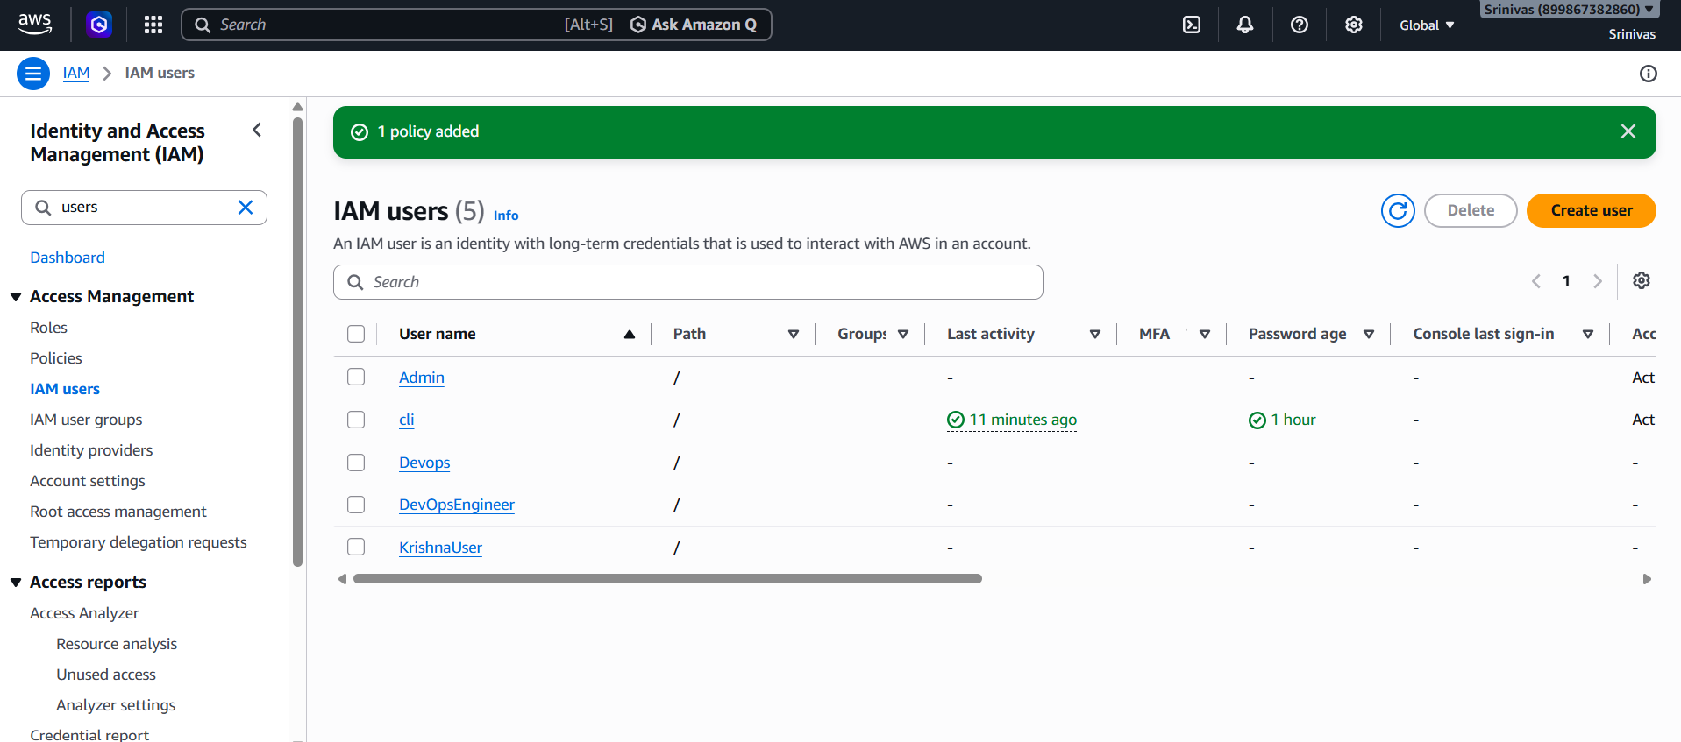
- 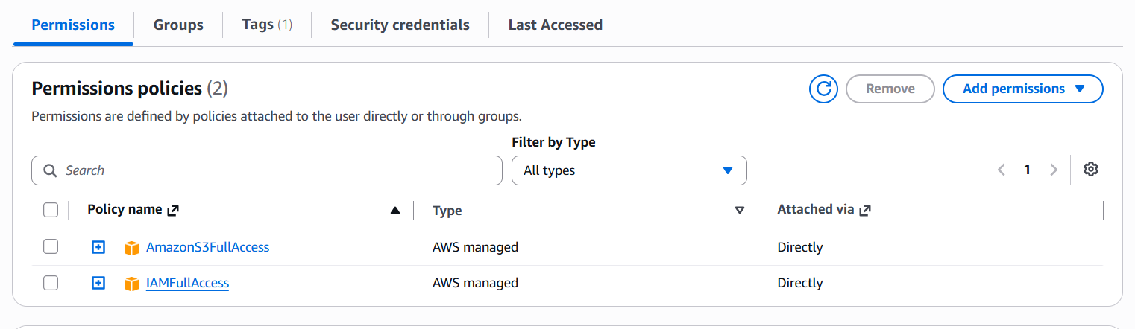

Task 2
Create an IAM group and assign EC2 ReadOnly access.
1. IAM → User Groups → Create Group.
2. Name it EC2ReadGroup.
3. Attach AmazonEC2ReadOnlyAccess.
4. Create the group.
Screenshot: Group and attached policy.
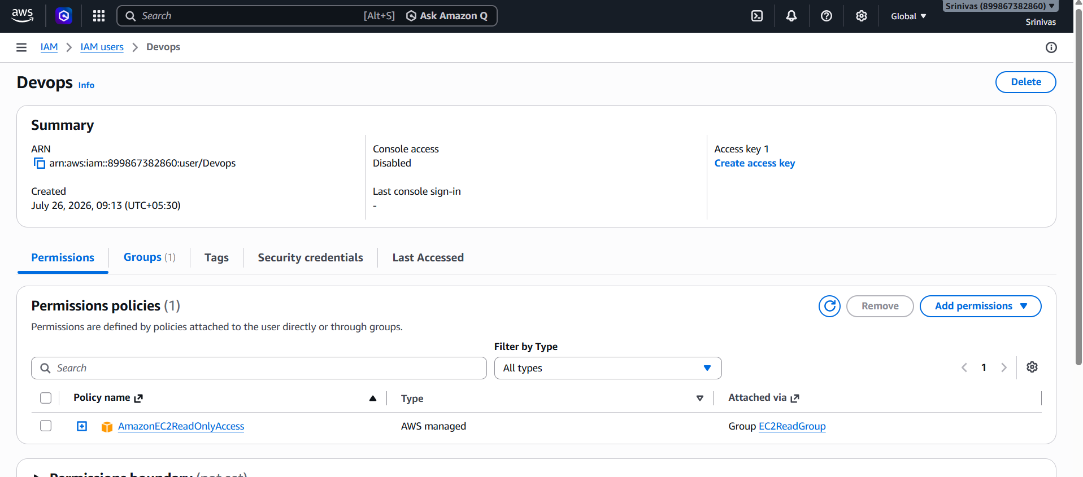

Task 3
Create a user named Devops and add it to the group.
1. IAM → Users → Create User.
2. Name: Devops.
3. Add user to EC2ReadGroup.
4. Create the user.
Screenshot: User and group membership.
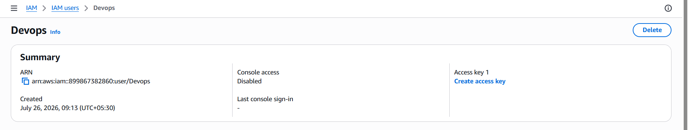

Task 4
Create an IAM user using a Bash script.
1. Install and configure AWS CLI.
2. Create create-user.sh.
3. Execute ./create-user.sh.
4. Verify DevOpsEngineer user with AmazonVPCFullAccess.
Screenshot: Script, terminal output, IAM user.
Paste Screenshot Here:
______________________________________________

Task 5
Create a region-specific EC2 IAM policy.
1. IAM → Policies → Create Policy.
2. Paste JSON restricting EC2 to ap-south-1.
3. Name it EC2-Mumbai-Only.
4. Attach to DevOpsEngineer.
Screenshot: JSON policy, created policy, attached permissions.
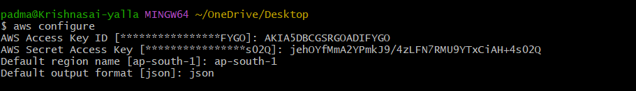
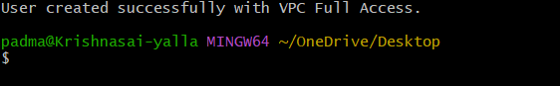
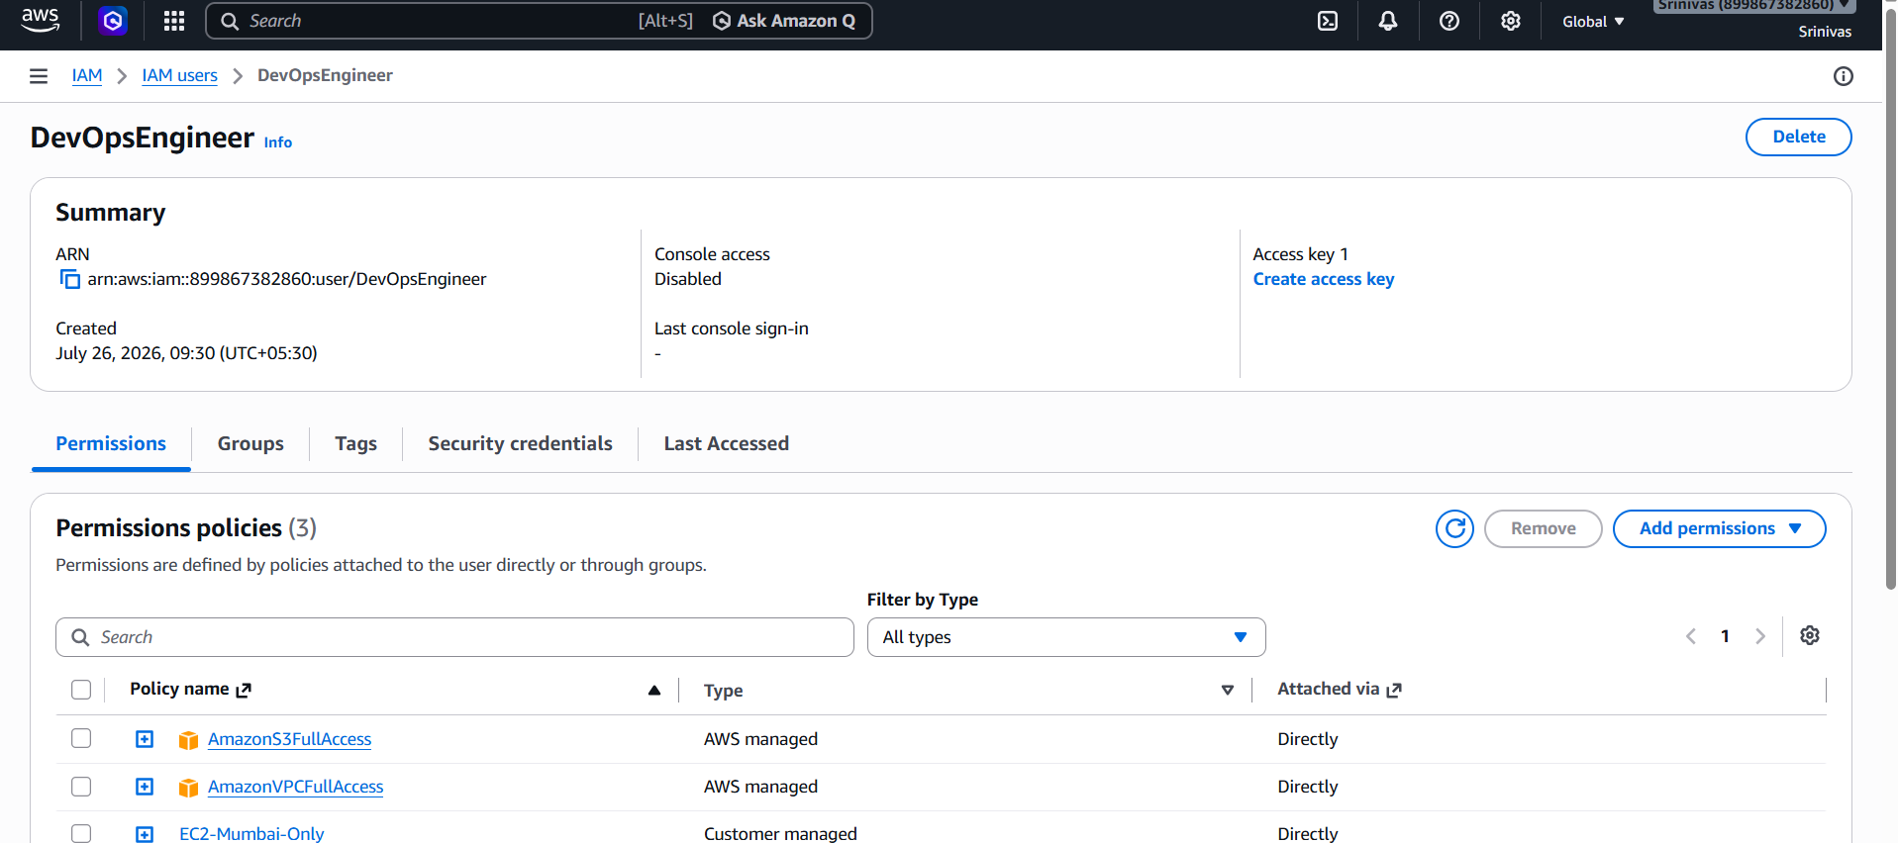

Task 6
Configure Cross-Account S3 Access.
1. Friend (Account B) creates S3 bucket.
2. Friend adds bucket policy allowing your IAM user ARN.
3. Verify AWS CLI identity using aws sts get-caller-identity.
4. Run aws s3 ls s3://purna-1-demo.
5. Confirm access succeeds.
Screenshot: Bucket policy, CLI output, successful access.
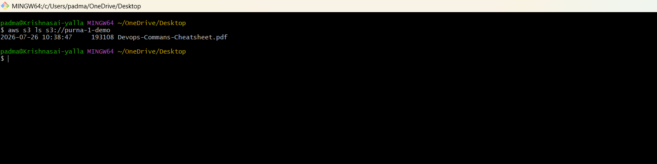

Conclusion
All IAM tasks were completed successfully, including user and group management, IAM policies, AWS CLI automation, and cross-account S3 access.

